Join us on September 9, 2023, to participate in Active Shooter Training for Police and Fire Rescue personnel.

Scouts can Earn the Messengers of Peace Award!

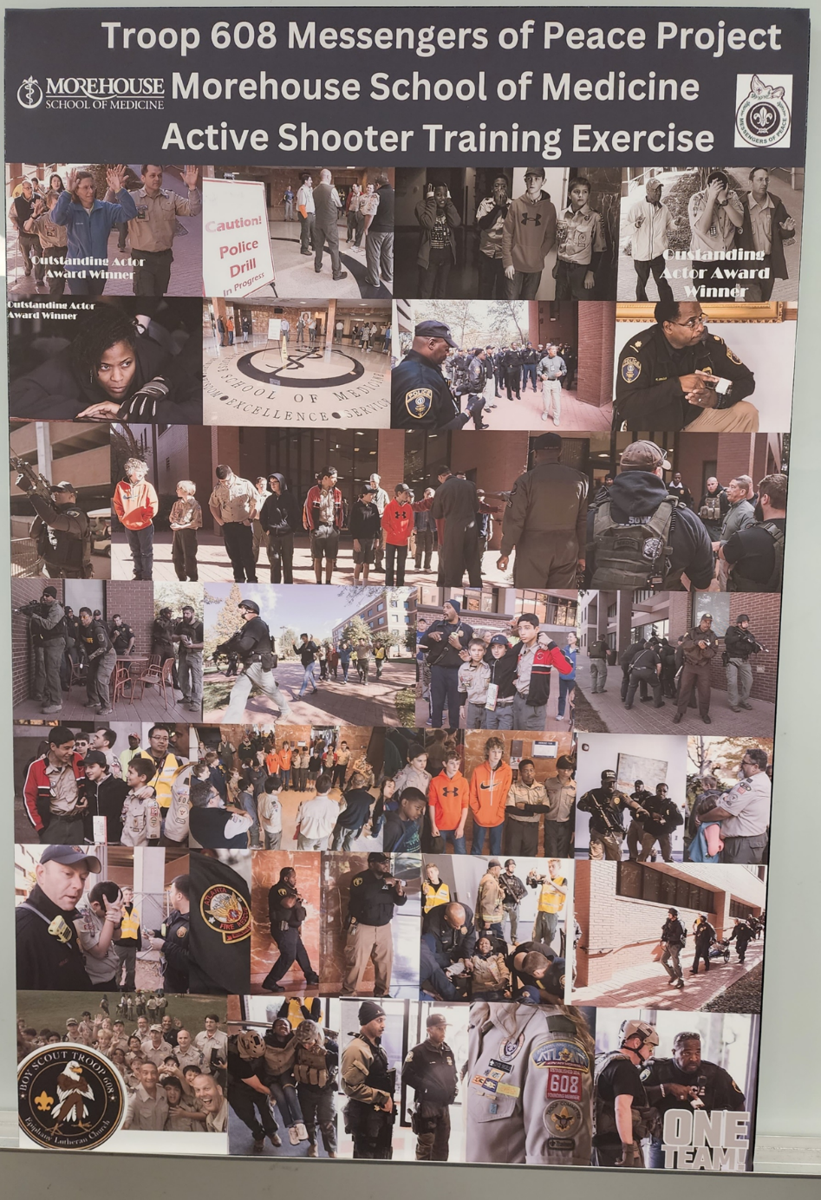

Register here

